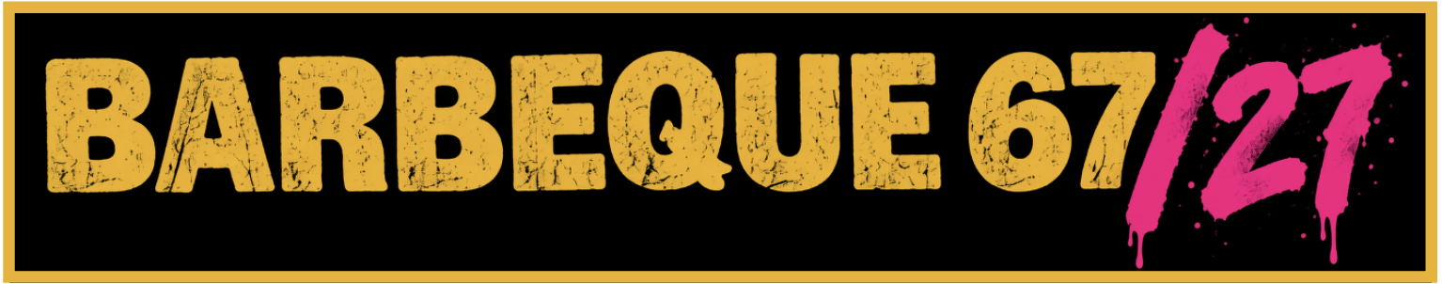
CREATIVE COMMUNITY FUND: Bursaries up to £1,000
What is the Fund?
A small bursary scheme empowering local artists, performers, and community groups to host activities during the Barbeque 67/27 festival in Spalding throughout May 2027.
Who is this for?
This fund is designed to unlock new grassroots opportunities and specifically supports individuals or groups who need financial assistance to make their creative project happen.

FESTIVAL THEMES & PROJECT IDEAS (PAST, PRESENT, POSSIBLE)
Barbeque 67/27 celebrates 60 years since Spalding’s legendary 1967 Barbeque 67 music festival (featuring Jimi Hendrix, Pink Floyd, and Cream). Rooted in live music, performance, and counterculture, your project should connect to one or more of our core themes:
- PAST: 1967 Heritage & Counterculture
- Theme: Commemorating Spalding’s unique place in British music history and 1960s culture.
- Project Ideas: Staging a 1960s tribute performance, a local band showcase featuring vintage-inspired sets, or a community banner/psychedelic street art project.

- PRESENT: Live Performance & Skill-Building
- Theme: Bringing people together in May 2027 through active, live creative expression and shared talent.
- Project Ideas: Organising pop-up busking trails, public DJ sets, poetry circles, acoustic open-mic nights, new and original music gigs, community choir performances, collaborative music sessions, or dance and drama rehearsals culminating in a live showcase.

- POSSIBLE: Grassroots Ambition & Future Talent
- Theme: Unlocking new grassroots opportunities and inspiring lasting creative ambition across Spalding.
- Project Ideas: Running beginner songwriting workshops, guitar/instrument masterclasses, youth band mentoring, or establishing collaborative community art projects, youth-led festival stages, and skill-sharing masterclasses in event production that leave a lasting creative legacy for local participants.

PRIORITY FOCUS AREAS
Although not exclusively, we are particularly excited to support events, workshops, or activities that:
- Build Community Skills: Teach or develop local skills in music, visual art, poetry, performance, or event production.
- Engage Local Residents: Involve young people, older generations, or underrepresented groups.
- Celebrate Local Heritage: Reflect Spalding's unique identity, heritage, or modern creative
community.

PAYMENTS AND REPORTING
Funding is subject to Arts Council England (ACE) project confirmation in late January 2027. Bursaries are available up to a maximum of £1,000.
- 100% Upfront Grant Payment (Feb/March 2027): Released in full upon signed agreement following ACE confirmation to cover your early materials, deposits, and production costs.
- Mid-Project Check-In (April 2027): A short, informal catch-up with the PPP team to offer support, check progress, and assist with any event logistics.
- Grantee Agreement: All successful applicants will sign a simple agreement outlining project commitments and grant conditions.
- Final Reporting & Receipts (by June 2027): After your event, you will submit a brief completion form, copies of spending receipts, and photos and/or videos capturing your activity.

SUBMISSION GUIDELINES
Please complete the application form on the next page and hand it to a team member, or return by email to pastpresentpossible@outlook.com by 15th January 2027. Keep answers concise—bullet points are welcomed!
Please note: A member of the Past Present Possible team may contact you after submission to clarify details or request additional information about your proposal.

